The Honorable Bernice B. Donald

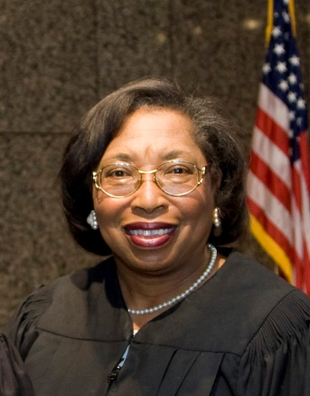

The Honorable Bernice B. Donald received her law degree from the University of Memphis Cecil C. Humphreys School of Law, a LLM from Duke University School of Law, and an honorary Doctors in Law from Suffolk University. Prior to being appointed to the U.S. Court of Appeals by President Barack Obama in 2011, she served on the U.S. District Court for more than fifteen years. Judge Donald is currently a member of the prestigious American Law Institute and the American Bar Association Judicial Division. Previously, she served as Chair of the American Bar Association (“ABA”) Center for Human Rights and recently chaired a committee which published an implicit bias resource book for judges and practitioners titled, Enhancing Justice: Reducing Bias. Judge Donald also served as Chair of the ABA Criminal Justice Section, focusing on issues concerning implicit bias, children of incarcerated parents, mass incarceration, and the collateral consequences of incarceration. Having previously served as Secretary of the American Bar Association (ABA), Judge Donald served in the ABA House of Delegates until August 2018. She has been faculty at the National Judicial College, the Federal Judicial Center, and the Judge Advocate General’s Legal Center & School. Judge Donald also served as faculty for the Federal Magistrate Judges Conference held in Portland, Oregon, where she was part of the panel titled, Thinking, Blinking, and Judging: Addressing Implicit Biases. She served as Jurist in Residence at American University, Washington University, University of Cincinnati School of Law, and the University of Georgia School of Law. In addition, she has served as faculty for international programs in more than twenty countries.
Judge Donald’s writings include the following: A Glimpse Inside the Brain’s Black Box: Understanding the Role of Neuroscience in Criminal Sentencing, 85 Fordham L. Rev. 481 (2016); Not Your Father’s Legal Profession: Technology, Globalization, Diversity, and the Future of Law Practice in the United States, 44 U. Mem. L. Rev. 645 (2014); Bringing Back Reasonable Inferences: A Short, Simple Suggestion for Addressing Some Problems at the Intersection of Employment Discrimination and Summary Judgment, 57 N.Y.L. Sch. L. Rev. 749 (2012-2013); The Not-So-New Normal of the Legal Profession: Facing and Confounding the Odds, 23 AM. U. J. GENDER SOC. POL’Y & L. 1 (2014); Immigrants and Other Cultural Minorities as Non-Traditional Plaintiffs: Culture as a Factor in Determining Tort Damages, 92 JUDICATURE 220 (2009); Fifty Years Later and Miranda Still Leaves Us With Questions, 50 TEX TECH L. REV. 1 (2017); The Dischargeability of Property Settlement and Hold Harmless Agreements in Bankruptcy: An Overview of § 523(a)(15), 31 FAMILY L. QUARTERLY 409 (1997); To This Tribunal the Freedman Has Turned: The Freedman’s Bureau’s Judicial Powers and the Origins of the Fourteenth Amendment, 79 LA. L. REV. 1 (2018); When the Rule of Law Breaks Down: Implications of the 1866 Memphis Massacre for the Passage of the Fourteenth Amendment, 98 U. Boston L. Rev. 1607 (2018); She Stands on Her Own, Amongst Many: The Women of the Tennessee Supreme Court, 86.3 Tenn. L. Rev. 593 (2019); and Implicit Bias: Should the Legal Community Be Bothered?, 2 J. PLI Press, 615 (2018).
Judge Donald has received over 100 awards for professional, civic, and community activities, including the Distinguished Alumni Award from the University of Memphis; the Martin Luther King Community Service Award; the Benjamin Hooks Award from the Memphis Bar Foundation; the prestigious Margaret Brent Award; the Spirit of Excellence Award; the John Pickering Award of Achievement; the University of Memphis Pillars of Excellence Award; and the Inaugural Liberty Award from the Tort, Trial and Insurance Section of the ABA. In 2020, at the request of the Labor 3 and Employment Law Section, the American Bar Association established “The Judge Bernice Bouie Donald Diversity and Inclusion Award,” and Judge Donald was presented with the inaugural award.

The Honorable ROGER A. PAGE
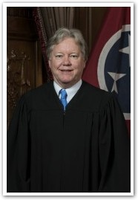

Justice Roger A. Page was sworn in as the newest member of the Tennessee Supreme Court in February 2016 after he was appointed by Governor Bill Haslam and unanimously confirmed by the Tennessee General Assembly. In August 2016, he was elected to serve until 2022, the remainder of the full term. He is the first appellate judge to be selected pursuant to the Constitutional amendment approved by the voters of Tennessee in 2014. Prior to assuming a seat on the Supreme Court, he served as an appellate judge on the Tennessee Court of Criminal Appeals from December 2011 to February 2016. While on the Court of Criminal Appeals he wrote more than 330 appellate opinions. Justice Page began his judicial career after being elected Circuit Court Judge in 1998. He presided over both civil and criminal trials in the 26th Judicial District, which includes Chester, Henderson, and Madison counties, from August 1998 to December 2011.
Justice Page received his law degree with high honors in 1984 from the University of Memphis School of Law where he ranked 4th in his class.
Before his experience on the bench, he was a law clerk for then-U.S. District Court Judge Julia Smith Gibbons from 1984-1985. He was an associate at Peterson, Young, Self & Asselin in Atlanta from 1985-1987. He practiced at Holmes, Rich, Sigler & Page in Jackson from 1987-1991. He was an assistant attorney general for the State of Tennessee in Jackson from 1991-1998.
Before his legal career, Justice Page was a chief pharmacist and assistant store manager for Walgreens in Memphis, where he worked from 1977-1984. He received a bachelor’s degree in Pharmacy in 1978 from the University of Tennessee College of Pharmacy in Memphis. He attended the University of Tennessee at Martin from 1973-1975 after graduating from Chester County High School in Henderson.

The Honorable Janice M. Holder (Ret.)

Janice Holder began her legal career in Pittsburgh, Pennsylvania, as a judicial clerk for the Honorable Herbert P. Sorg, Chief Judge of the United States District Court for the Western District of Pennsylvania. At the conclusion of her clerkship in 1977, she entered into private practice in Pittsburgh. She served as the solicitor for the Borough of McDonald, Pennsylvania, her hometown, for one year before moving to Memphis, Tennessee, where she practiced law for ten years.
Janice was elected judge of the Circuit Court of Shelby County, Tennessee, in 1990. In 1993, she was appointed the coordinating judge of the silicone gel breast implant cases in West Tennessee by the Tennessee Supreme Court. She served as a member of the National Conference of Chief Justices Mass Tort Litigation Committee and the Silicone Gel Breast Implant Subcommittee and was appointed the subcommittee’s chair in 1996.
She also served on the Tennessee Supreme Court as a special justice during its November 1994 session.
In 1996, she was appointed to the Tennessee Supreme Court by Governor Don Sundquist, and in 2008, she became the first woman to serve as Chief Justice of the Court. Justice Holder was a member of the Board of Directors and Second Vice President of the Conference of Chief Justices in 2011. She retired from the Supreme Court on September 1, 2014, after nearly twenty-four years of judicial service.
She currently serves as an alternative dispute resolution neutral and has been appointed as both a special master and a special judge She is listed as a Tennessee Supreme Court Rule 31 General Civil Mediator. In 2016, she joined the American Arbitration Association National Roster of Arbitrators and in 2018 was a co-founder of the Memphis ADR American Inn of Court.

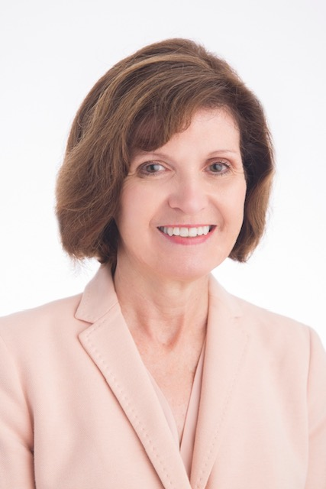

Cheryl Light

Cheryl Light is general counsel and corporate secretary for Home Federal Bank of Tennessee where she has been in-house counsel since 2000. She also served as associate general counsel at First American National Bank from 1989-1999. Prior to going to an in-house position, Ms. Light worked in private practice concentrating on insurance defense, civil litigation, bankruptcy, and creditor representation. Ms. Light received her undergraduate degree from East Tennessee State University and her law degree from Wake Forest University School of Law.

She is a member of the Knoxville Bar Association, the Hamilton Burnett Inns of Court and the Knoxville Executive Women’s Association. Active in the community, Ms. Light is past-president of the YWCA of Knoxville and the Great Smoky Mountains Association. She is currently serving on the boards of the Holston Foundation and the Joining Hands Health Clinic.

Daya Naef

Daya has been a business owner for almost 20 years focusing mainly on real estate, construction, law, and professional development.
She ran her own law firm and a small partnership. She is currently coaching, consulting, and practicing conflict management as a trainer. Mediator, and arbitrator.
She received her JD and International Law Certificate from Loyola University in New Orleans Law School and her Master in Liberal Arts from Spring Hill College. She is an Associate Certified Coach with the International Coaching Federation, a Certified Mediator, and a graduate and affiliate of Accomplishment Coaching and Leadership Program.
When not working, she draws, makes travel plans, and spends time with her parents and their multiple dogs and cats.

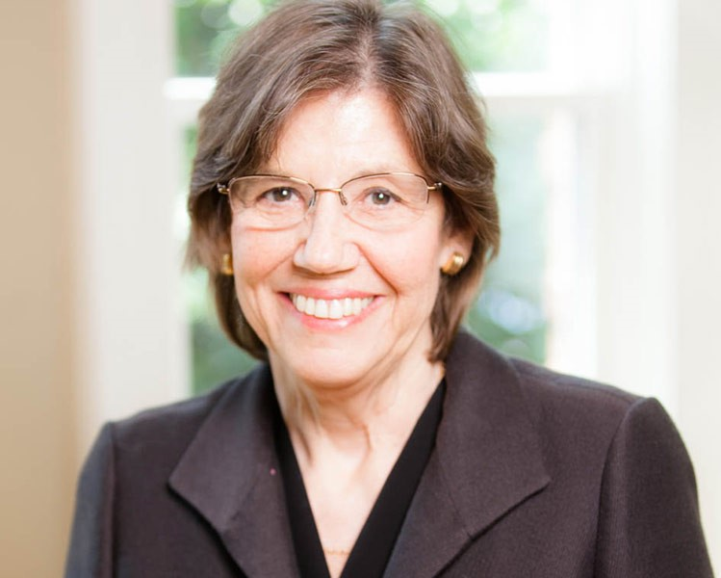

Margaret L. Behm

After beginning her legal career in 1976 at Legal Services of Middle Tennessee, Inc., Behm and Marietta Shipley in 1980 founded Shipley and Behm, the city’s first all-woman law firm. “Back then, women just weren’t taken seriously as business owners or lawyers,” Behm says. “I wanted to run my own business and demonstrate that women could not only run a law firm, but also be good lawyers.”
Today, Behm’s practice concentrates on business law, employment, municipal law, land use, estate planning, bankruptcy, and commercial litigation. Behm also serves as general counsel for the Metropolitan Transit Authority.

Denise Ceule

As Chief Legal Officer at Navi Health, Denise Ceule leads on all legal affairs and brings deep experience in securities law, Denise has spent nearly all of her career in health care, previously serving as vice president, law — corporate and securities at Change Healthcare, formerly Emdeon, where she also served as senior legal counsel. Denise served as senior legal counsel at CVS Caremark as well and worked on the complex 2007 merger of Caremark Rx, Inc. and CVS Corporation. When not at work, Denise enjoys dancing with her daughter in the kitchen, spending time with friends, and searching antique stores for vintage art.

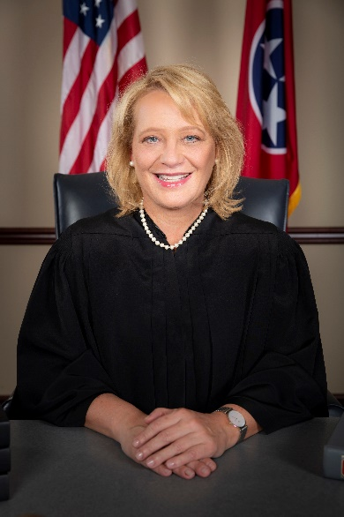

Chancellor Anne C. Martin
Chancery Court, Part II

Anne C. Martin is judge of Part II of the Chancery Court of Davidson County, Tennessee. Effective November 1, 2019, the Tennessee Supreme Court appointed Chancellor Martin as the Business Court Docket judge for the State of Tennessee.
Chancellor Martin earned a Bachelor of Arts Degree from Smith College in 1989 and her Juris Doctorate from Vanderbilt University School of Law in 1992. She began her practice with the law firm of Dodson, Parker & Behm, P.C. In July 2004 she joined the law firm of Bone McAllester Norton PLLC where she concentrated her practice in the areas of commercial litigation and employment law. She has represented both employers and employees of many different companies, as well as individuals with a diverse array of business problems. Chancellor Martin is proud of the clients she has helped over the years and of the recognition she has received for her leadership among her peers.
Chancellor Martin loves the law and attributes her love for the profession to the excellent legal mentorship she received. She enjoys being able to share the skills she learned from her mentors with aspiring students. To this end, Chancellor Martin was an Adjunct Professor at Belmont University College of Law where she taught a course in client counseling. She is currently an Adjunct Professor at the Nashville School of Law teaching sales and secured transaction courses.
A natural networker, Chancellor Martin is very passionate about the numerous charities she works with, especially those benefiting children. She has never met a stranger, nor does she stay still for long, pouring her energy into both work and play.
Chancellor Martin resides in Nashville with her son, Clay, and their yellow lab, Lily.
Roberta Scott Pettis

As President and Founder of FocusWorks Consulting Group, Roberta Scott Pettis leverages decades of experience in corporate training and development to the benefit of executives, their companies and their employees. She is a former Director of Education and Training for Hospital Corporation of America (HCA) who spent 15 years traveling from coast to coast guiding individuals and teams in leadership development, new system implementations and Diversity, Equity & Inclusion (DEI) service initiatives. Roberta brings that deepand-varied experience along with a powerful skill set to FocusWorks, where she has assembled, equipped and empowered an exceptional team of uniquely qualified trainers. A Nashville native, Roberta graduated with a Bachelor of Science in Health Administration and Planning from a joint program with Meharry Medical College and Tennessee State University (TSU) before going on to earn her Master’s Degree in Business Administration from TSU. She is certified as a Master Facilitator with Ntrinsx, an innovative and highly interactive “social intelligence” tool that helps people understand and appreciate each other’s intrinsic value. With FocusWorks, Roberta is able to deliver her one-of-a-kind training when and where it is needed most. As an African American woman and a successful executive who grew up in the South and came up in corporate boardrooms and C-suites, she brings a uniquely personal-and-powerful perspective to the Diversity, Equity & Inclusion conversation. Roberta stays actively involved with several organizations that serve the Nashville community. While at HCA, she received the Frist Humanitarian Employee Award, recognizing her volunteer work with several non-profit boards and schools. Roberta currently serves on the Advisory Council of the Women’s Business Collaborative (WBC); Advisory Board of The Table organization; Leadership Development Chair for Bordeaux North Nashville Chamber of Commerce; Member of National Association of Women Business Owners (NAWBO), Nashville Area Chamber of Commerce, and Nashville Black Chamber of Commerce.

Kristi F. Lewis
Corporate Compliance Officer and Vice President
Ms. Lewis, CHC, CHPC, joined Covenant in 2016 and has more than 17 years of experience in the healthcare industry. She has held several positions with emphasis in litigation, compliance, employment, and contract negotiating, drafting, and management. During her career, Kristi has served as the Associate Counsel of Litigation and Employment at SpecialtyCare, Inc.; as Privacy Officer and Senior Legal Counsel at Healthways, Inc.; and as the Privacy Officer and Special Counsel to the Commissioner at the Department of Children’s Services. She was also a litigating attorney for the Department of Health and Mental Health and Substance Abuse Services. As an adjunct professor, Kristi taught several courses in Meharry Medical College’s Master of Public Health Program, several courses in Argosy University’s undergraduate program, and she taught Business Law at the University of Phoenix and Tennessee State University. Kristi earned her Juris Doctor from the University of Memphis and is licensed to practice in the state of Tennessee.

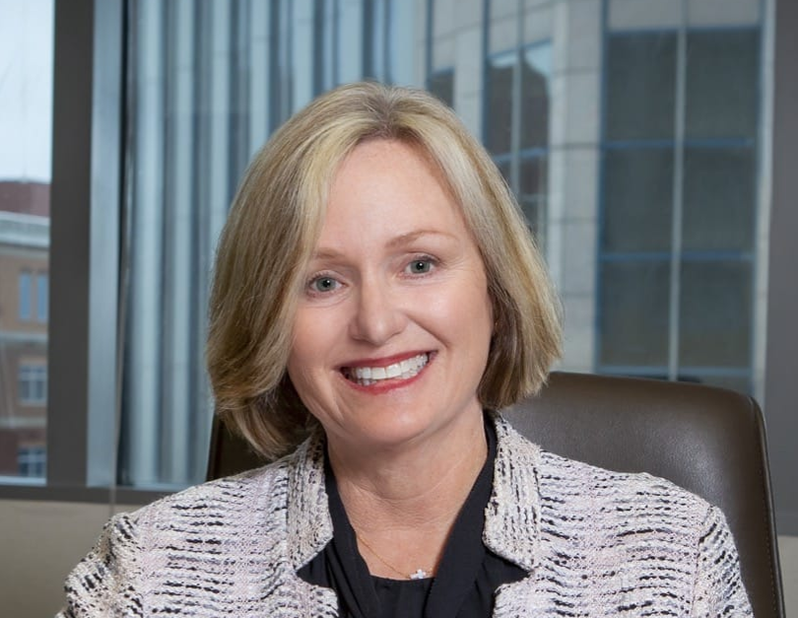
Wendy Longmire

Ms. Longmire is an experienced and tenacious litigator, who excels in and out of the courtroom.
A member of Ortale Kelley since 1987, Ms. Longmire has honed her skills representing major companies and individuals who find themselves in conflict. Her career began with a judicial clerkship with Judge Walter C. Kurtz of the Fifth Circuit Court of Davidson County, Tennessee. Ms. Longmire, a partner since 1993, has tried hundreds of matters in jury and nonjury settings. She handles complex civil litigation involving death and personal injury alleged to have resulted from professional negligence and simple negligence, healthcare liability, products liability, negligent design and employment disputes.
In addition to her active litigation practice, Ms. Longmire is a Rule 31 listed General Civil Mediator. Ms. Longmire routinely presents seminars involving complex tort liability. She stays active in the community. She is a Past-President for Tennessee Lawyers Association for Women and serves as Vice-Chancellor of the Episcopal Diocese of Tennessee. She volunteers her time to: The Legal Aid Society of Middle Tennessee and The Cumberlands; The Davidson County Mock Trial Competition; The Nashville Symphony; and serves on the Nashville Bar Association Continuing Legal Education Committee. Ms. Longmire previously served on the Nashville Bar Association Board of Directors and served as Second Vice President of the Nashville Bar Association. Ms. Longmire was also named Best of the Bar 2017 for her skills in litigation.

Mary Flipse
Chief Legal and Administrative Officer of Tivity Health, MARY FLIPSE has been with the organization since 2011.Mary has been a critical member of the executive team and an advisor to the CEO during a period of significant change, growth, and transformation. Mary was one of a small team of Tivity Health Executives who steered the company through the announcement of a definite agreement to acquire Nutrisystem in December 2018. Prior to the Nutrisystem deal, Mary was instrumental in the divesture of Tivity Health’s population health division in 2016, a move that redefined the company’s strategic direction and added nearly $1 billion of valuation to the company.

JULIE BHATTACHARYA PEAK

JULIE BHATTACHARYA PEAK is Resident Attorney for Liberty Mutual Insurance Company where she manages a diverse team of trial attorneys the defense of its insureds across the State of Tennessee. Ms. Peak is a 1997 graduate of Rhodes College and 2000 graduate of The University of Memphis Cecil C. Humphrey’s School of Law. Ms. Peak served as the judicial law clerk to the Honorable William C. Koch at the Tennessee Court of Appeals and, thereafter, was an equity partner at Ortale, Kelley, Herbert & Crawford where she learned first-hand the tremendous value of genuine mentorship and sponsorship in the development of her professional career.
Ms. Peak has been involved in bar leadership since participating in the inaugural class of the Tennessee Bar Association Leadership Law program in 2004. Ms. Peak has chaired the TBA Tort and Insurance Practice Group, served on the TBA’s Diversity Committee, as well as the Bench and Bar Committee. She also serves on the Board of the Tennessee Lawyer’s Association for Women where she co-chairs its annual Empowerment Conference. Nationally, Ms. Peaks serves as cochair of the Insurance Law Committee of the National Asian Pacific American Bar Association (NAPABA). Ms. Peak is also an active member of the Nashville Bar Association, having been named a Fellow of the Association in 2012. Ms. Peak participates on the Diversity and Inclusion Committee and has served as a speaker for various NBA programming. To contribute to her greater community, Ms. Peak serves as a Trustee of The Oak Hill School, where she chairs the Diversity, Equity and Inclusion Committee and is legal advisor to the Board of Mother to Mother. Ms. Peak is eager to bring her passion for growth and support of diverse professionals within the organization and fostering a culture of inclusivity and respect within the profession as a whole.

Lauren Holloway

Lauren Holloway’s practice focuses on general litigation including commercial litigation, construction, trucking, employment, nursing home liability, premises liability and products liability defense in the firm’s Memphis office. She assists a variety of clients including, but not limited to, restaurants and retail establishments, trucking companies, manufacturing plants and concrete companies. Lauren serves on MGC’s Trucking: Rapid Response Team. Prior to joining MGC, Lauren represented clients in high exposure insurance defense cases, as well as served in employment and bankruptcy matters. She started her career as a Judicial Law Clerk to the Honorable Bernice Bouie Donald, who was a Bankruptcy Judge for the Western District of Tennessee. When it comes to her clients, Lauren tries to recognize their needs and be available when it is most convenient for them. Lauren expects her clients to look to her for expertise in the legal field, and transparency during the litigation process; she takes pride in demonstrating a high level of technical excellence in handling her client’s cases and timely delivering information, evaluations and results. In her free time, Lauren enjoys customizing and riding motorcycles, golfing, traveling and spending time with her family and two “fur babies,” Dottie and Nelson.

